**Associate Data Analyst in SQL DataCamp**

**Course 6: Functions for Manipulating Data in PostgreSQL**

**Overview of Common Data Types**

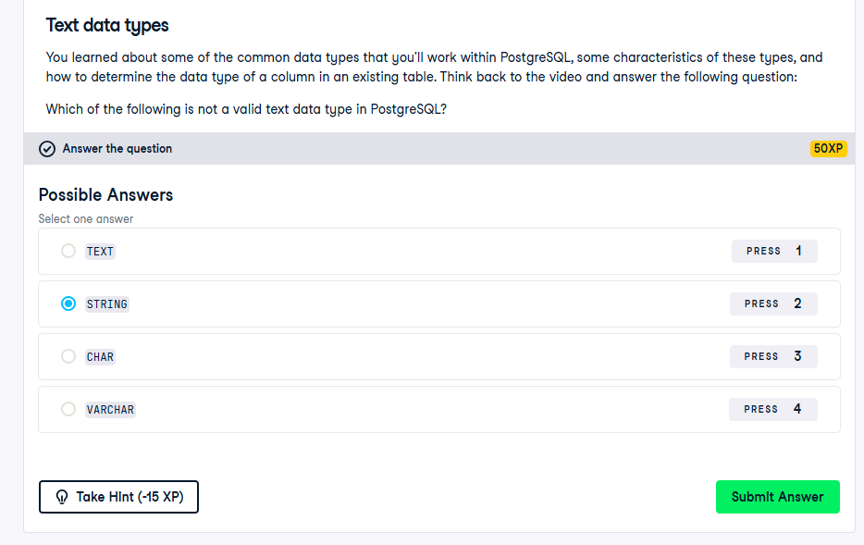

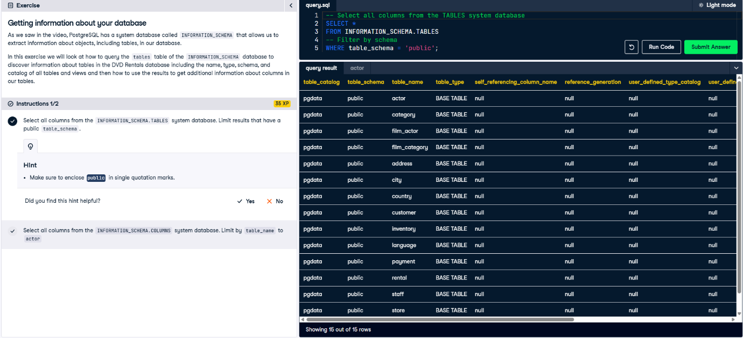

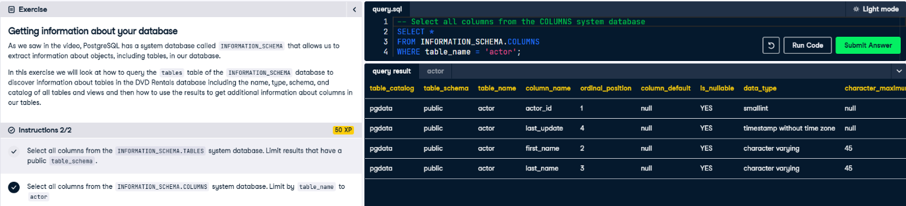

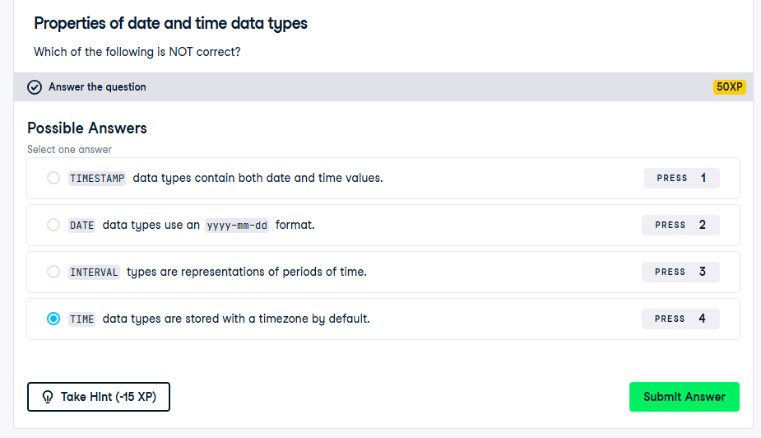

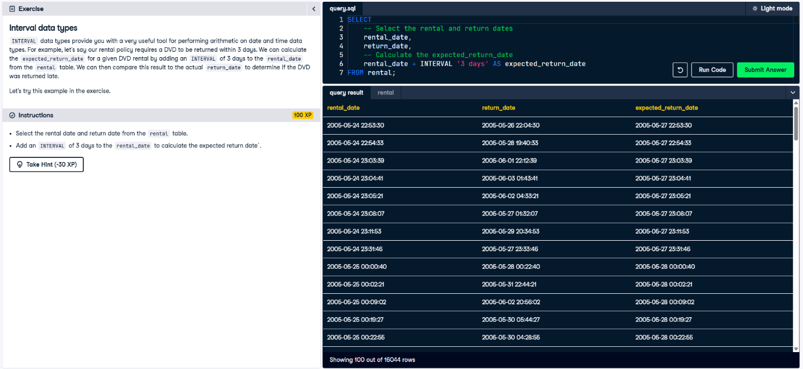

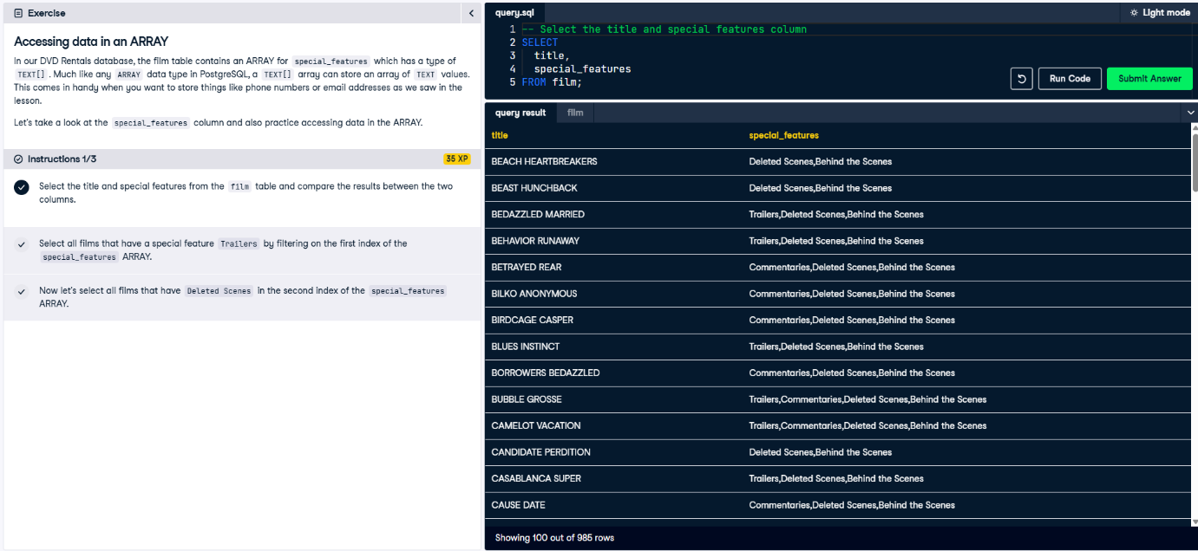

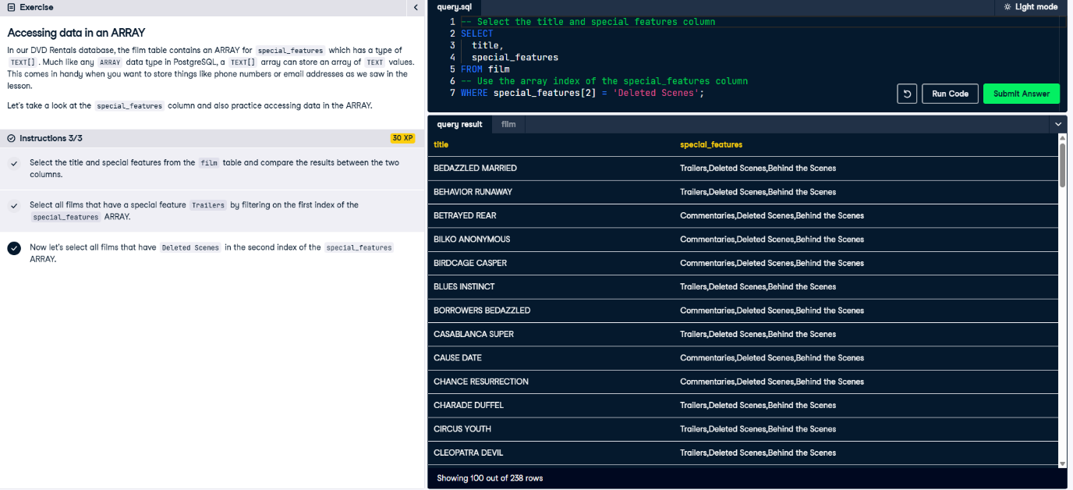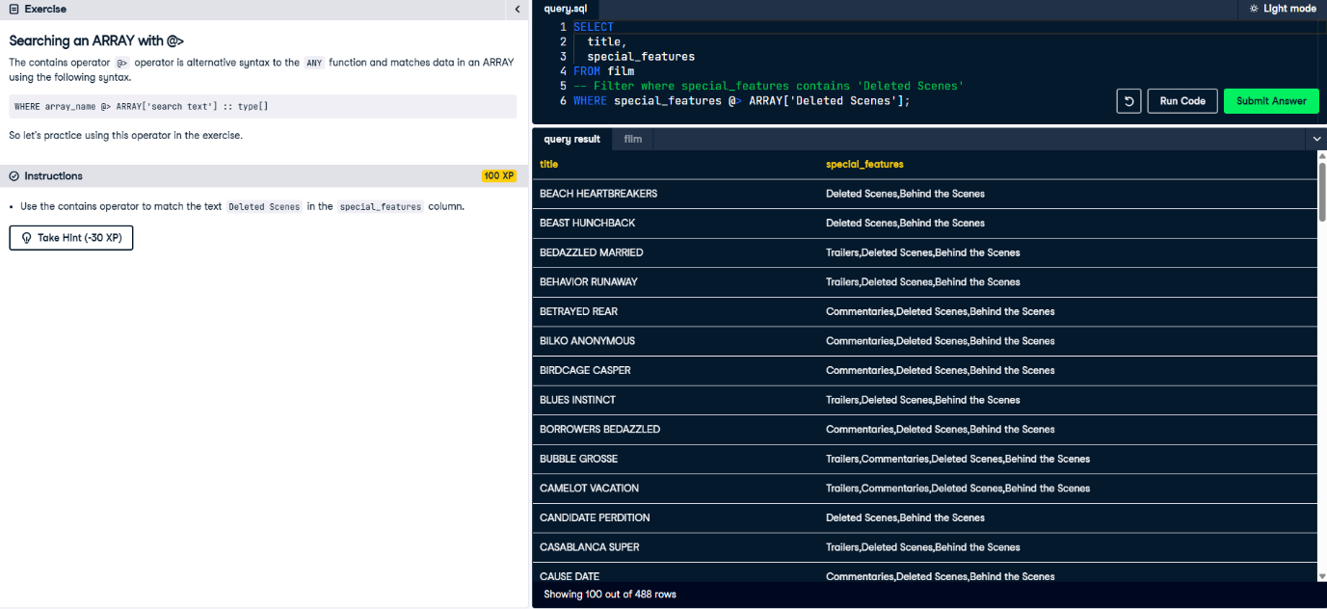

**Working with DATE/TIME Functions and Operators**

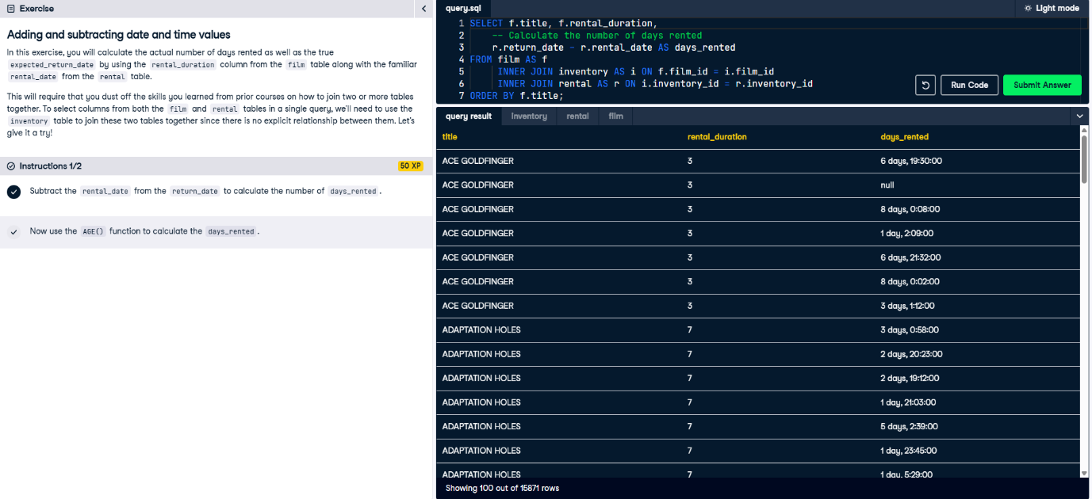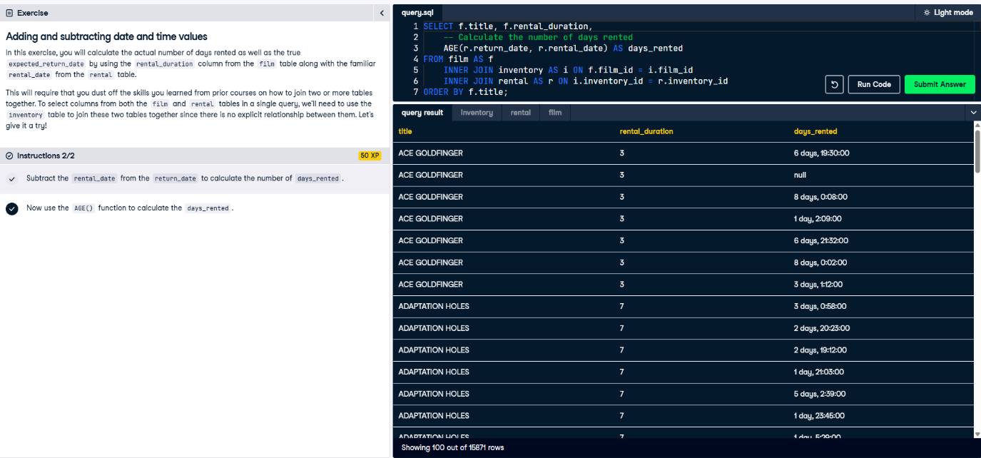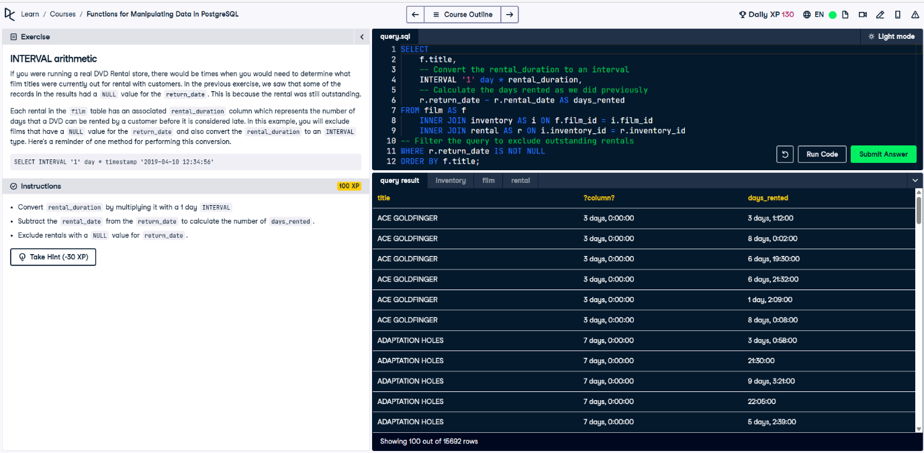

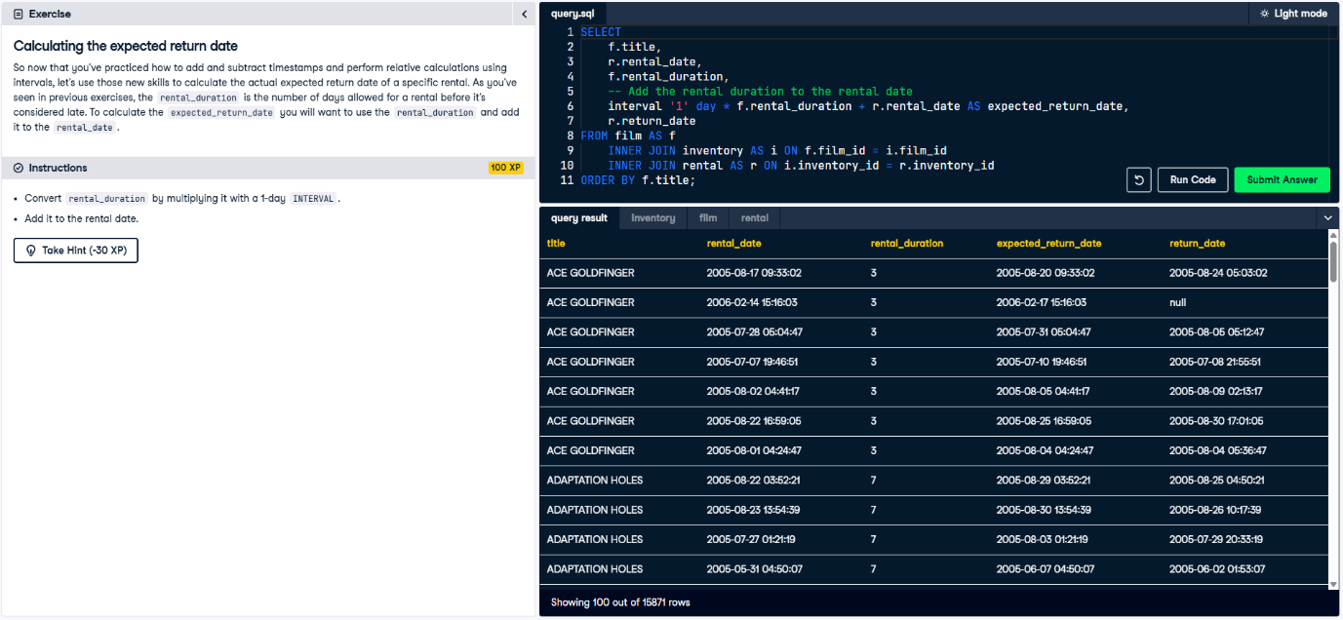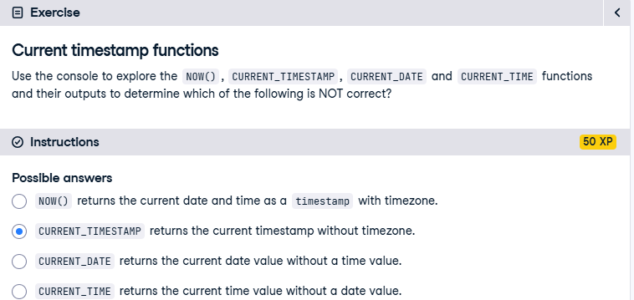

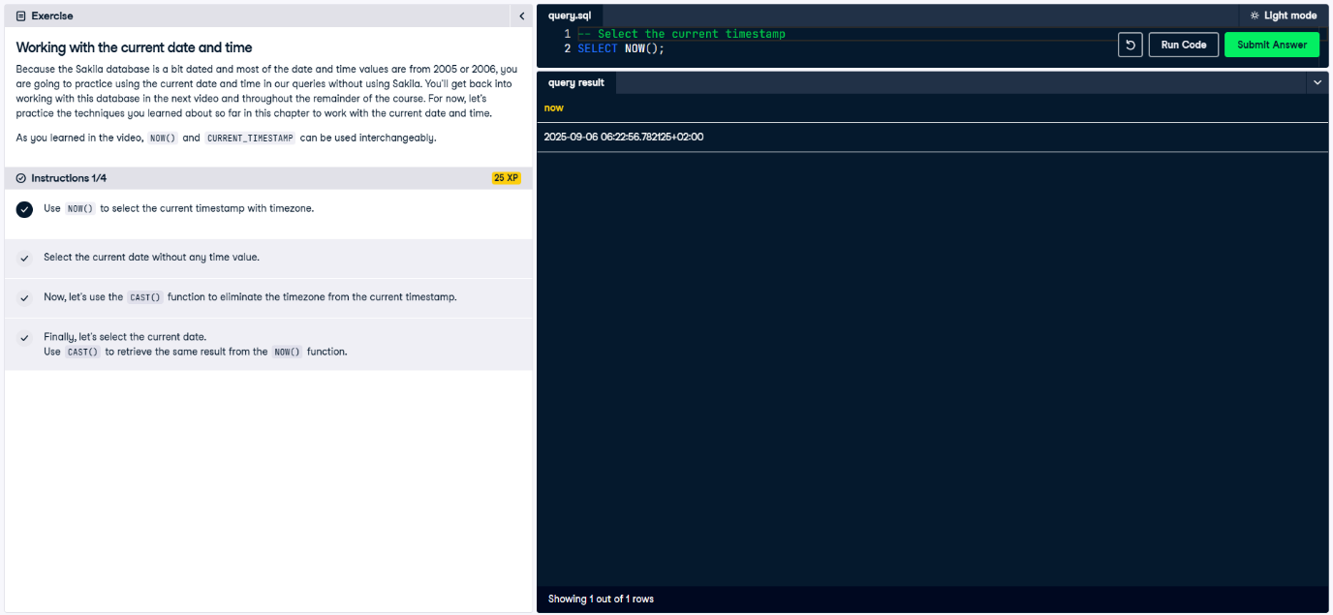

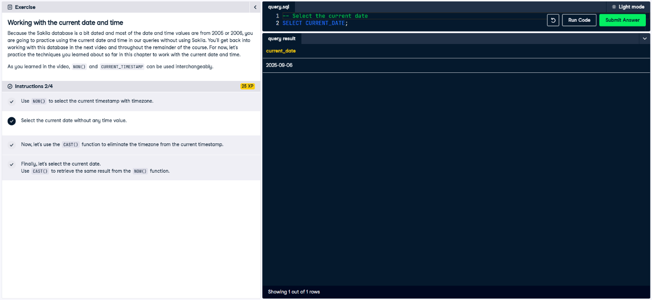

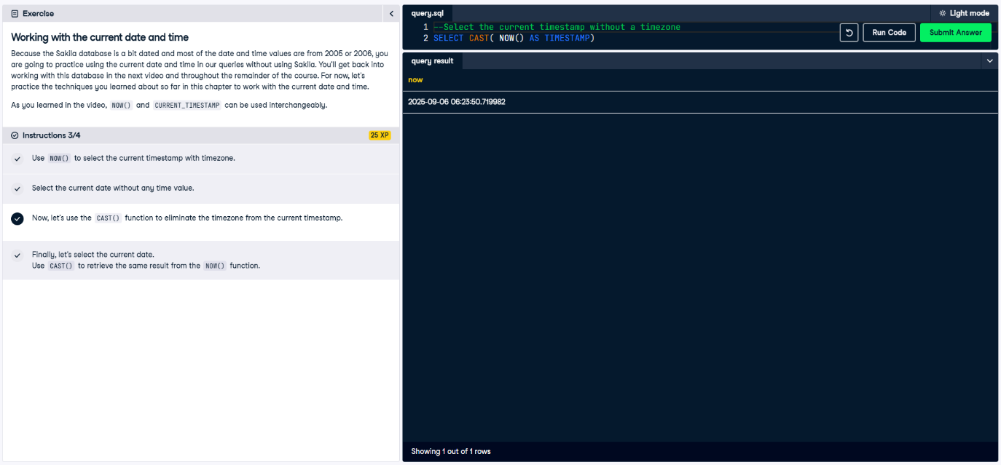

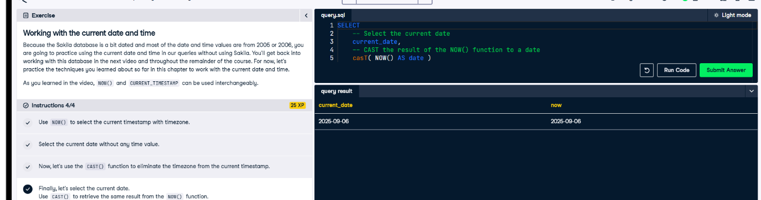

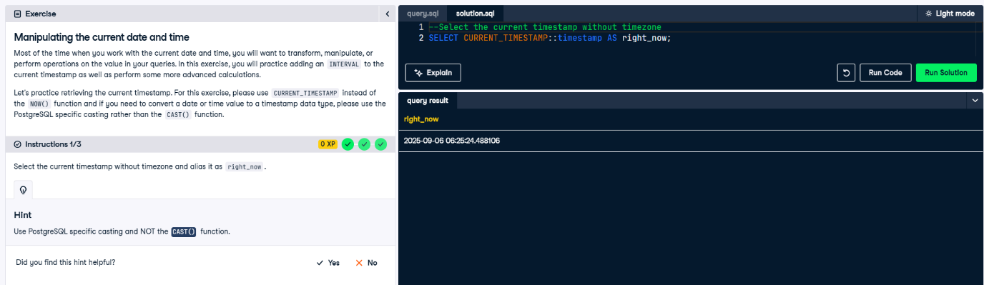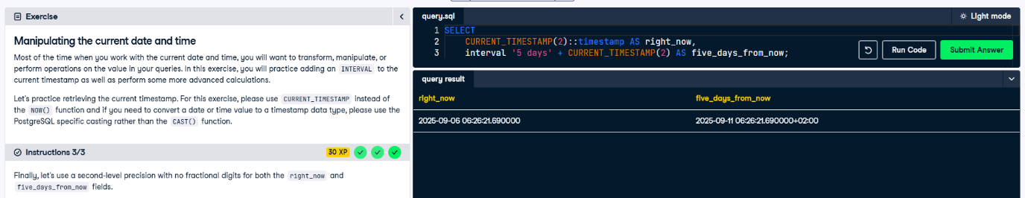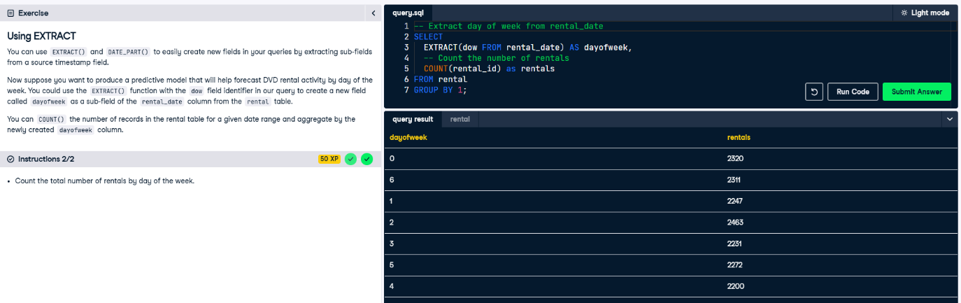

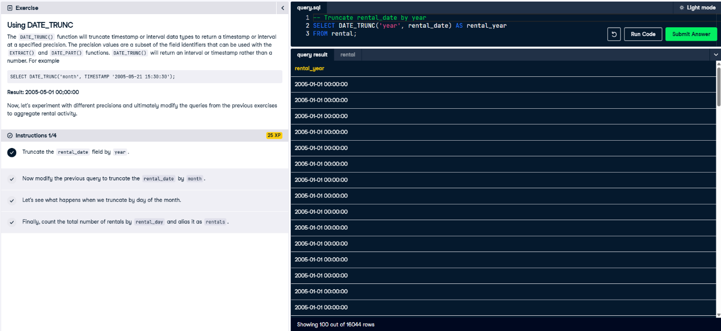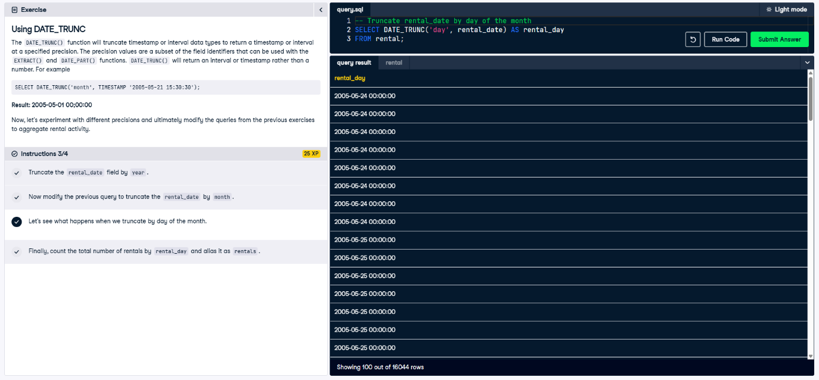

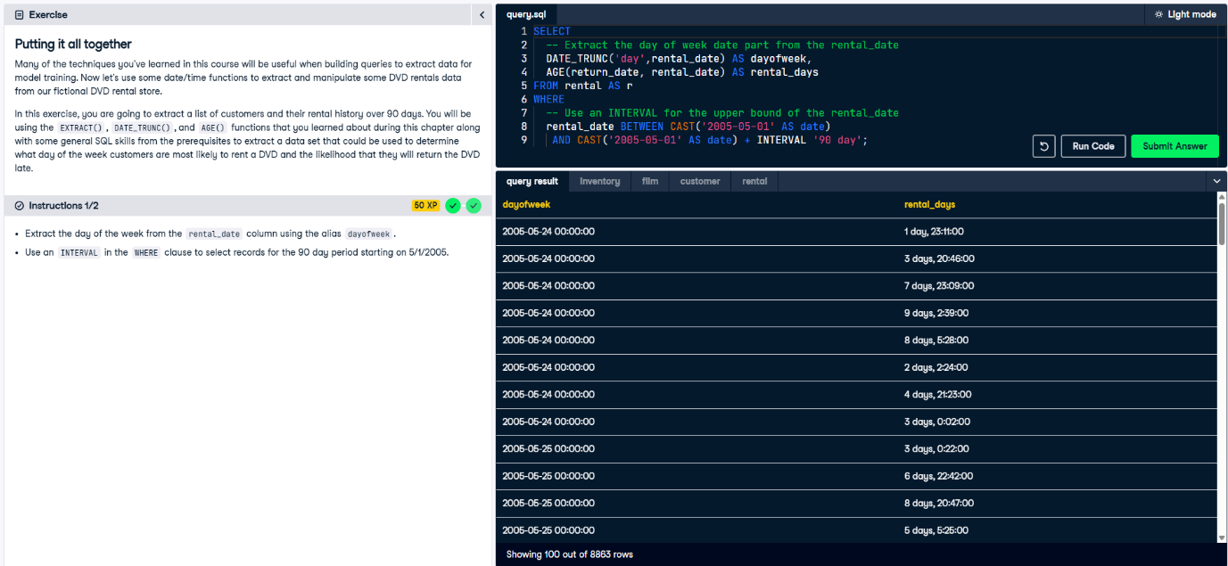

**Parsing and Manipulating Text**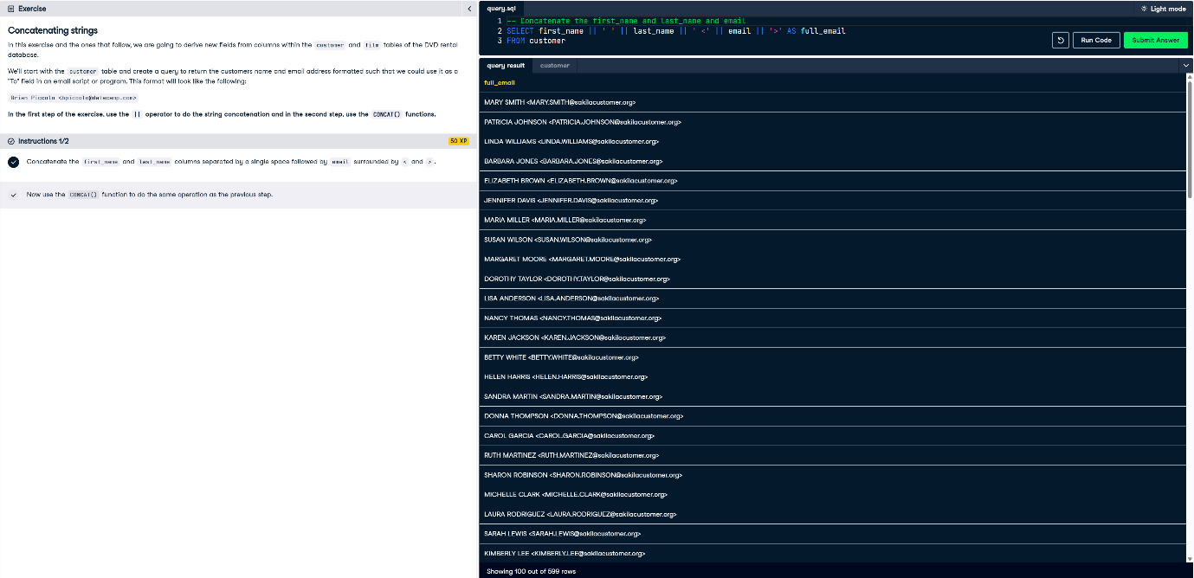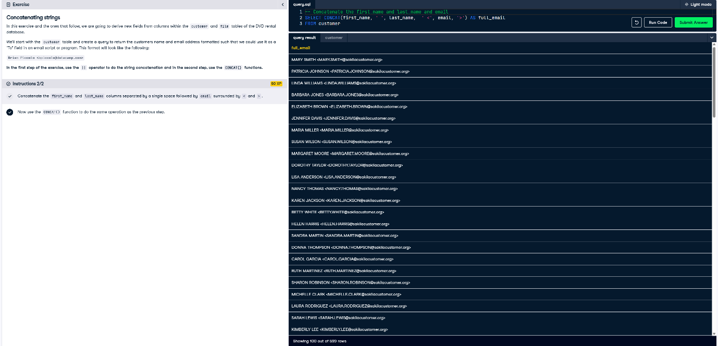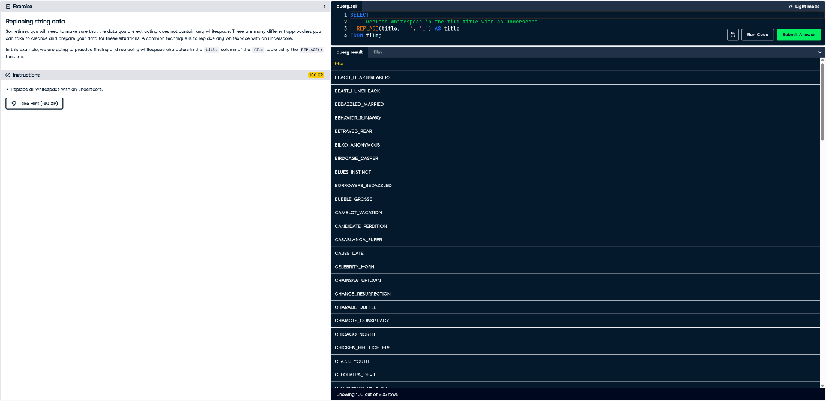

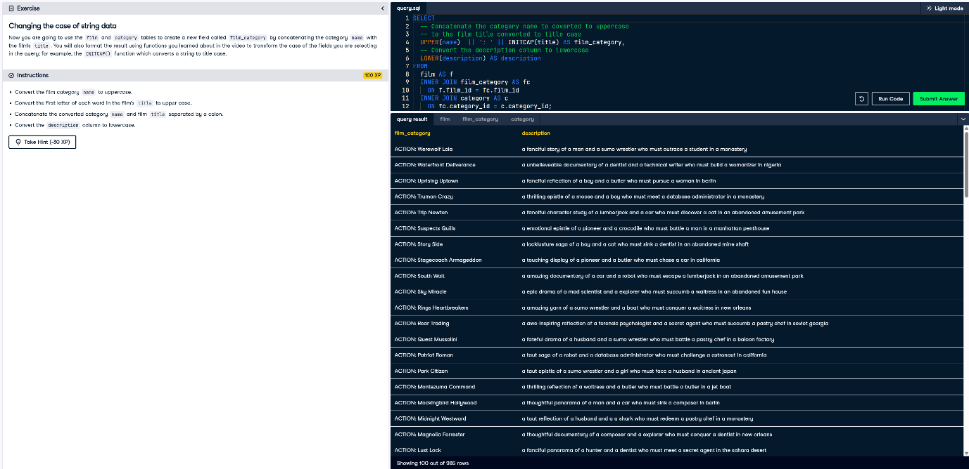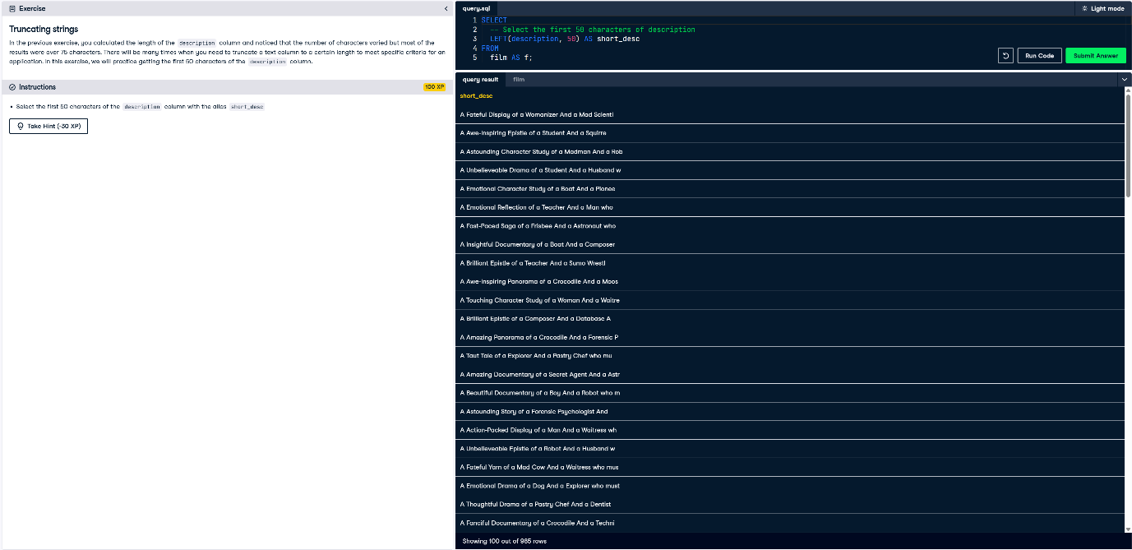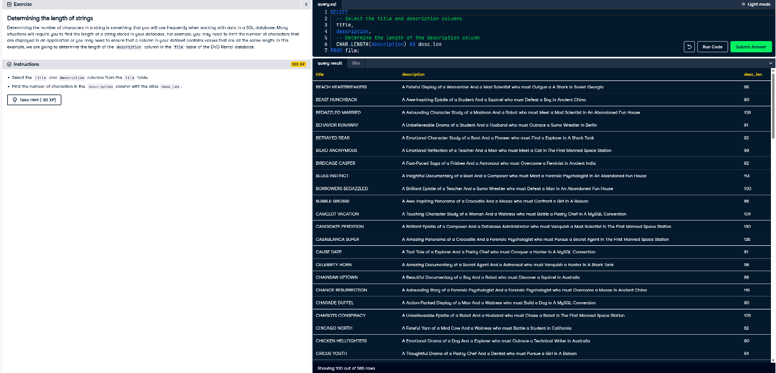

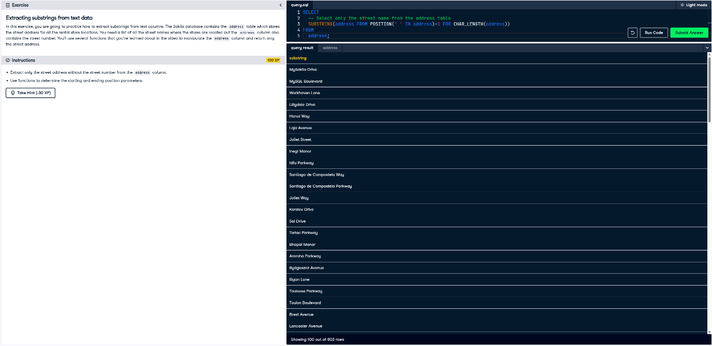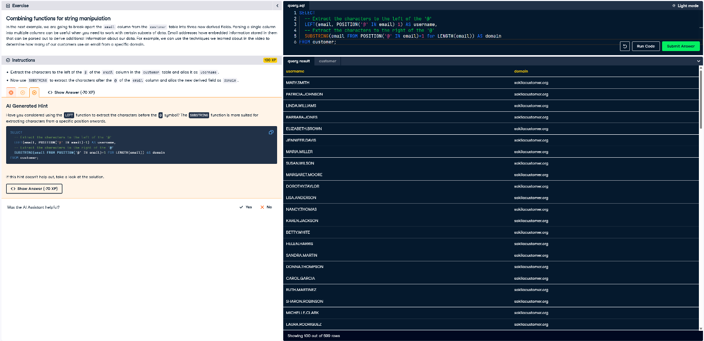

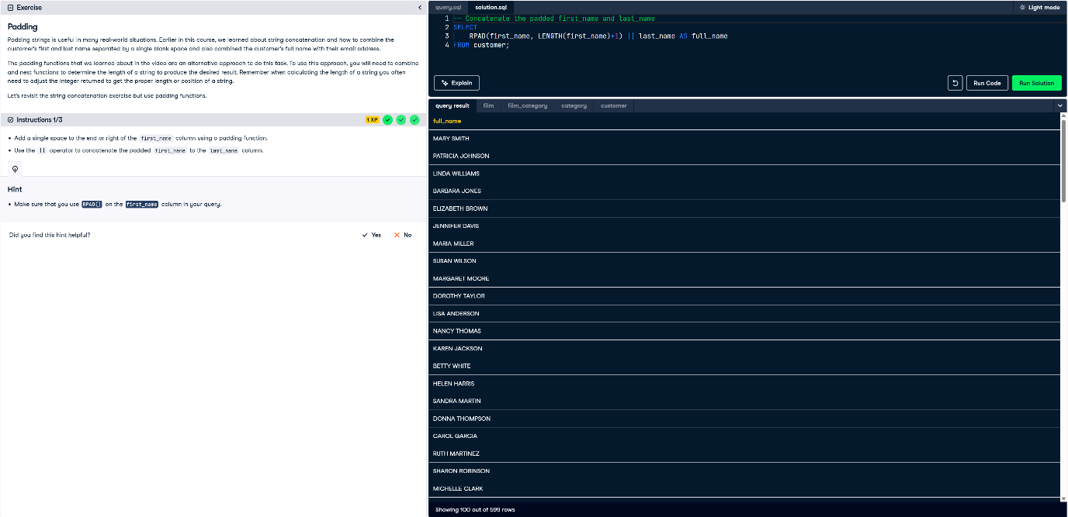

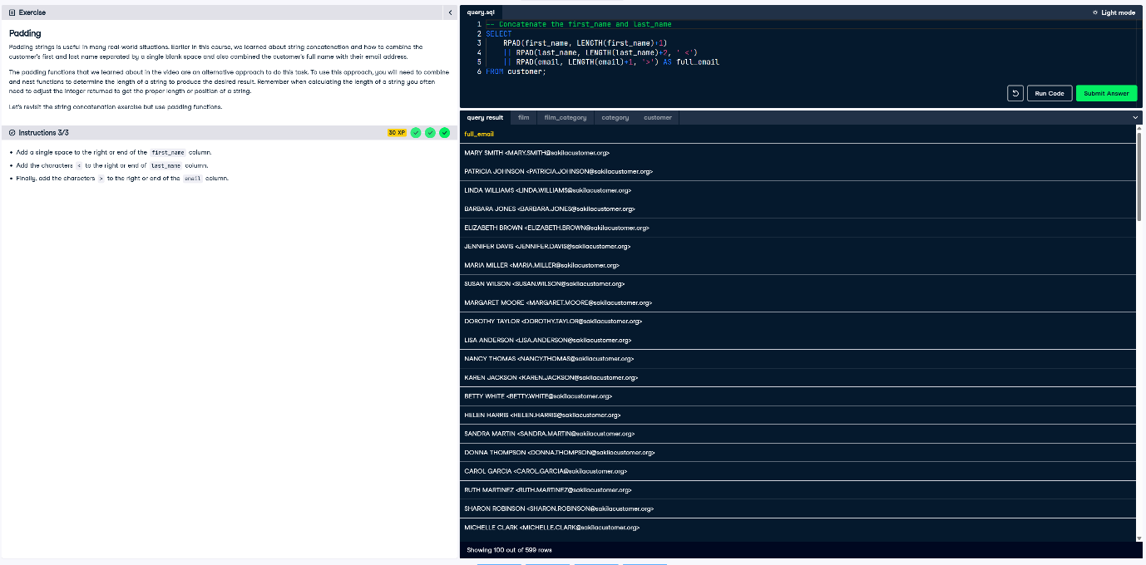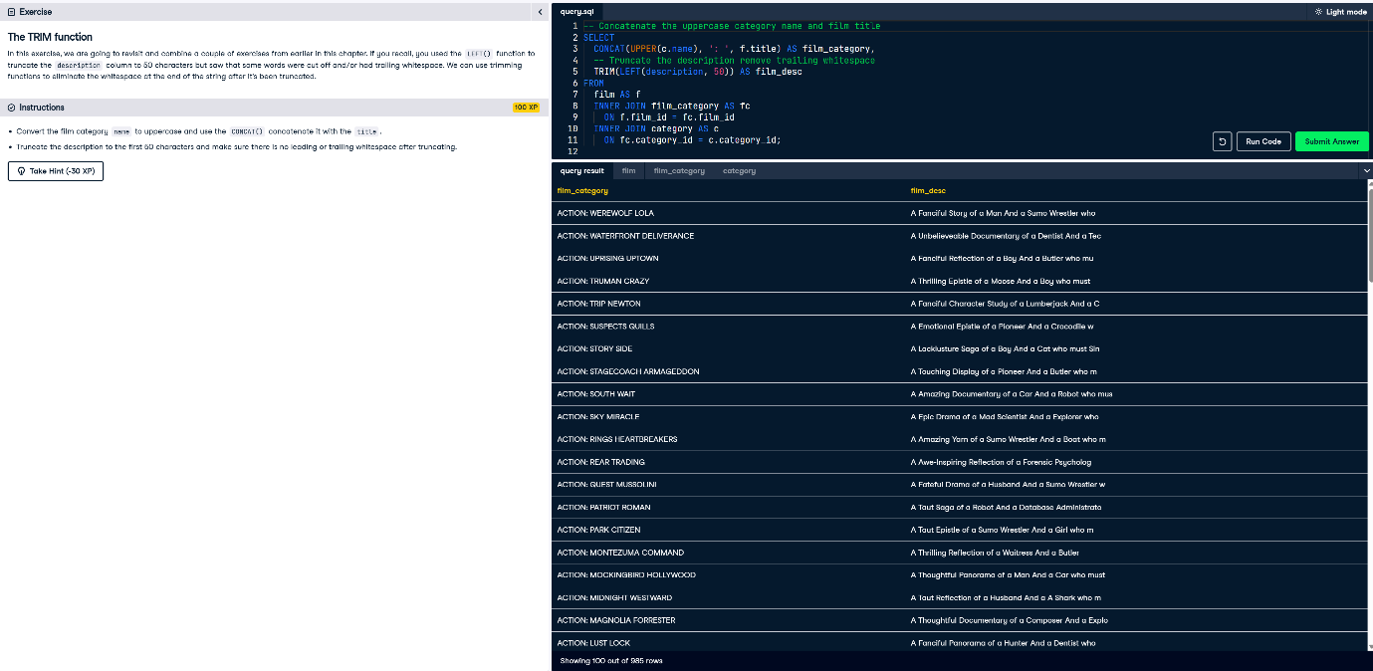

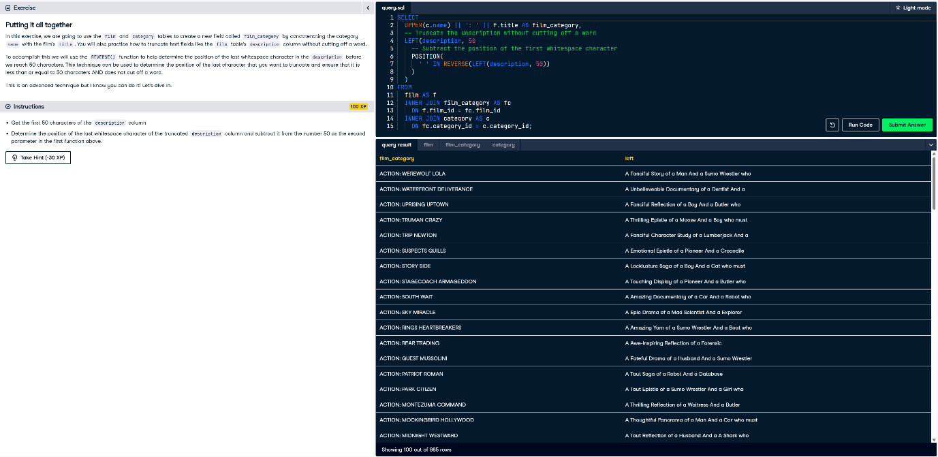

**Full-text Search and PostgresSQL Extensions**

